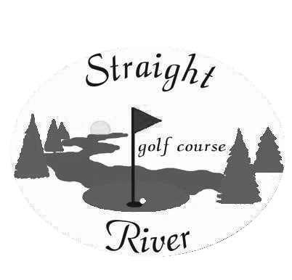

Membership Application

Name:_____________________________________________

Address:____________________________________________

City, Sate,Zip:_____________________________________________________________________________

Phone Number:______________________________________

E-Mail:____________________________________________

Date of Birth:_______________________________________

Date Sold:__________________________________________

Membership MN Tax Total AMOUNT

$450.00 + $30.94 = $480.94 ____________

TOTAL SALES __________
Straight River Golf Course

An Understanding With Our Membership…

- Members, Guests and Public Players alike must check-in with the golf shop staff before playing the golf course. To ensure a position on the tee box for you and your guests, tee times are required.

- For the benefit of all players, our Members will be committed to playing the holes in the designated order or as prescribed by the golf shop staff as necessary

- Our Members agree to set the example for all guests and public play, by staying out of all areas on the course marked as ground under repair or otherwise protected for the sake of improved playability for Members and guests of Straight River Golf Course.

- Our Membership is a pre-paid greens fee program for 1 year (thru 12-31-18), and applies to “open play” periods at the course during the Golf Season. Open play tee times can be made up to 7 days in advance.

- Open Play is defined as; any time there is not an organized event (i.e. outings/leagues/club tournaments or groups). To play in these events you must pay the associated fees the event.

- Our 7-day Membership is applicable anytime Monday through Friday and on Saturdays, Sunday and Holidays. There are no Refunds, Exchanges or Transfers of this Membership for any reason.

- Members, Guests and Public Players will not play the golf course during periods when a portion of the holes (or the entire course) is closed due to weather, special events or golf course maintenance.

- Straight River Golf Course will be solely responsible for distribution of all alcoholic beverages at the facility, and therefore as Members you will agree that you and your guests will not bring any beverages or alcoholic beverages onto the property that were not purchased at Straight River Golf Course. This is consistent with Minnesota law.

- Straight River Golf Course Member’s golf cart rental will always be set at our current Rack Rate for 18 holes. Members are not allowed to bring their own private cart onto the property, they are also not eligible for any type of unlimited cart plans of any kind.

- Failure to comply with these rules can result in termination from the club with no refund of membership.

______________________________ _____________________________________ ____________
Member Name Member Signature Date

